Frame Relay is a packet-switching network protocol that is designed to work at the data link layer of the network. It is used to connect Local Area Networks (LANs) and transmit data across Wide Area Networks (WANs). It is a better alternative to a point-to-point network for connecting multiple nodes that require separate dedicated links to be established between each pair of nodes. It allows transmission of different size packets and dynamic bandwidth allocation. Also, it provides a congestion control mechanism to reduce the network overheads due to congestion. It does not have an error control and flow management mechanism.

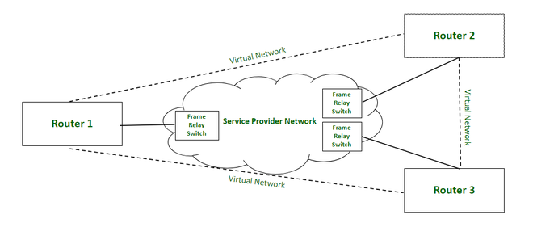

*Frame Relay Network*

**Working:**

Frame relay switches set up virtual circuits to connect multiple LANs to build a WAN. Frame relay transfers data between LANs across WAN by dividing the data in packets known as frames and transmitting these packets across the network. It supports communication with multiple LANs over the shared physical links or private lines.

Frame relay network is established between Local Area Networks (LANs) border devices such as routers and service provider network that connects all the LAN networks. Each LAN has an access link that connects routers of LAN to the service provider network terminated by the frame relay switch. The access link is the private physical link used for communication with other LAN networks over WAN. The frame relay switch is responsible for terminating the access link and providing frame relay services.

For data transmission, LAN’s router (or other border device linked with access link) sends the data packets over the access link. The packet sent by LAN is examined by a frame relay switch to get the Data Link Connection Identifier (DLCI) which indicates the destination of the packet. Frame relay switch already has the information about addresses of the LANs connected to the network hence it identifies the destination LAN by looking at DLCI of the data packet. DLCI basically identifies the virtual circuit (i.e. logical path between nodes that doesn’t really exist) between source and destination network. It configures and transmits the packet to frame relay switch of destination LAN which in turn transfers the data packet to destination LAN by sending it over its respective access link. Hence, in this way, a LAN is connected with multiple other LANs by sharing a single physical link for data transmission.

Frame relay also deals with congestion within a network. Following methods are used to identify congestion within a network:

1. **Forward Explicit Congestion Network (FECN) –**  
   FECN is a part of the frame header that is used to notify the destination about the congestion in the network. Whenever a frame experiences congestion while transmission, the frame relay switch of the destination network sets the FECN bit of the packet that allows the destination to identify that packet has experienced some congestion while transmission.
2. **Backward Explicit Congestion Network (BECN) –**  
   BECN is a part of the frame header that is used to notify the source about the congestion in the network. Whenever a frame experiences congestion while transmission, the destination sends a frame back to the source with a set BECN bit that allows the source to identify that packet that was transmitted had experienced some congestion while reaching out to the destination. Once, source identifies congestion in the virtual circuit, it slows down to transmission to avoid network overhead.
3. **Discard Eligibility (DE) –**  
   DE is a part of the frame header that is used to indicate the priority for discarding the packets. If the source is generating a huge amount of traffic on the certain virtual network then it can set DE bits of less significant packets to indicate the high priority for discarding the packets in case of network overhead. Packets with set DE bits are discarded before the packets with unset DE bits in case of congestion within a network.

**Types:**

1. **Permanent Virtual Circuit (PVC) –**  
   These are the permanent connections between frame relay nodes that exist for long durations. They are always available for communication even if they are not in use. These connections are static and do not change with time.
2. **Switched Virtual Circuit (SVC) –**  
   These are the temporary connections between frame relay nodes that exist for the duration for which nodes are communicating with each other and are closed/ discarded after the communication. These connections are dynamically established as per the requirements.

**Advantages:**

1. High speed
2. Scalable
3. Reduced network congestion
4. Cost-efficient
5. Secured connection

**Disadvantages:**

1. Lacks error control mechanism
2. Delay in packet transfer
3. Less reliable

## Features of frame relay:

Some important features of frame relay are :

1. Frame relay operates at a high speed (1.544 Mbps to 44.376 Mbps).

2. Frame relay operates only in the physical and data link layers. So it can be easily used in [Internet](https://ecomputernotes.com/computernetworkingnotes/services-and-applications/what-is-internet).

3. It allows the bursty data.

4. It has a large frame size of 9000 bytes. So it can accommodate all local area network frame sizes.

5. Frame relay can only detect errors (at the data link layer). But there is no flow control or error control.

## **Frame Format**

The frame format used in frame relay.

* • The DLCI length is 10 bits
* • There are two EA locations. The value of the first one is fixed at 0 and the second at
* • 1 is set in the DE (Discard Eligibility) for the part that can be discarded first when congestion occurs
* • The data size may vary up to 4096 bytes.

## Frame relay layers

• Frame relay has only two layers i.e. physical layer and data link layer.

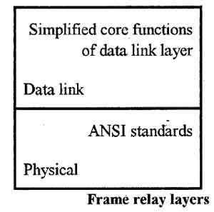

### Physical layer

• Frame relay supports ANSI standards.

• No specific protocol is defined for the physical layer. The user can use any protocol which is recognized by ANSI.

### Data link layer

• A simplified version of HDLC is employed by the frame relay at the data link layer.

• A simpler version is used because flow control and error correction is not needed in frame relay.

## The need for frame relay:

• The frame relay is being used for a number of reasons. Some of the important reasons are as follows:

1. Higher data rates.

2. It allows transfer of bursty data.

3. It has lower overheads.

• Let us discuss these points one by one.

### 1. Higher Data Rates

It allows transfer of bursty data.

• If the LANs located at physically distant places are to be connected to each other then there are two options available to do this.

1. Interconnect them using the T lines.

2. Interconnect using the frame relay.

• Fig. (a) Shows four such LANs interconnected via T-lines. The T-lines offer a high data rate but they make point to point connectiol1$. Hence we need 6 T-lines to connect each LAN to the remaining three.

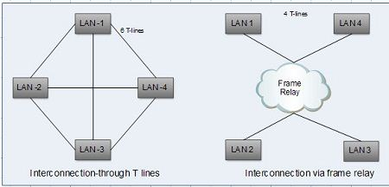

• Now refer Fig. (b) in which the LANs are interconnected via a frame relay. This requires only 4 T-lines. The saving increases with increase in the number of LANs.

• For the direct interconnection of Fig.(a), once a T-line is used, we have to pay a fixed charge for it irrespective of its usage because it is a leased line.

• The T-lines of Fig.(a) may be fully utilized sometimes and not utilized at all at other times.

• The frame relay network can handle data rates upto T-3 transmission i.e. 44.376 Mbps.

### 2. Can handle bursty data:

• The data being sent from a source to destination is not of continuous/constant nature.

• Instead it is bursty in nature. That means a large amount of data (data burst) is sent suddenly, then for sometime there is very little or no data.

• The T-lines are not equipped to handle such bursty data because they offer a constant data rate.

• The frame relay can tackle this problem. It supports a minimum average data rate and can handle the bursty data.

### 3. Lower overheads:

• In frame relay network, there are no acknowledgements sent from the switches back to the sender.

• There is no intermediate error check. The error checking takes place only at the destination.

• The intermediate host/switch does not keep a copy of the packet forwarded to the next host/switch. This saves a lot of [memory](https://ecomputernotes.com/fundamental/input-output-and-memory/memory) space of the hosts and switches.

• All this lead to reduced overheads.

## Frame relay architecture:

• Frame relay can provide two types of virtual circuits.

1. Permanent Virtual Circuits (PVC).

2. Switched Virtual Circuits (SVC).

• Fig. Shows the frame relay network connected to [internet](https://ecomputernotes.com/computernetworkingnotes/services-and-applications/what-is-internet). The routers connect LANs and WANs in the Internet.

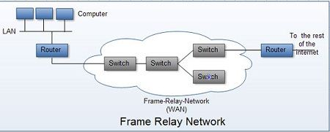**Virtual Circuits:**

The virtual circuits in frame relay are called as Data Link Connection Identifier (DLCI).

This is actually a number which identifies a virtual circuit in frame relay.

**Switches:**

• The switches in frame relay are supposed to route frames. For this each switch has a table.

• The routing procedure is same as that in the data transfer mode except for one change. VCIs are replaced by DLCIs.

## How frame relay works?

• Frame relay can support the Permanent Virtual Circuit (PVC) as well as Switched Virtual Circuits (SVC).

• Whether to use PVC or SVC is decided by the user, based on the data transmission requirements and the budget.                                 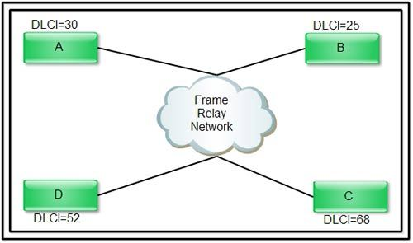

• The Frame Relay works on the basis of virtual circuits. These virtual circuits are created and used in the data link layer.

• Each virtual circuit is identified by a number called Data Link Connection Identifier (DLCI).

• When a virtual circuit is established, a DTE (Data Transmission Equipment) is provided with a DLCI which it can use to communicate with the remote DTE.

• Assume that a virtual circuit has been established between computers A and C using the DLCI numbers of Fig.

• Then [computer](https://ecomputernotes.com/fundamental/introduction-to-computer/what-is-computer) A uses DLCI = 68 (i.e. that of C) while sending a packet from A to C. On the other hand, [computer](https://ecomputernotes.com/fundamental/introduction-to-computer/what-is-computer) C uses DLCI = 30 (that of A) while sending a packet from C to A.

• The DLCI numbers are assigned permanently if PVC IS being supported and on a per connection basis if SVC is supported.

**Frame relay switching:**

• A frame relay uses the concept of switching in order to route packet from the sender to receiver.

• Each switch is a special type of computer that can forward packets based on the address contained in the packet.

• Fig. shows the basic frame relay network.

• In Fig. there are three frame relay switches which are connected to several computers.

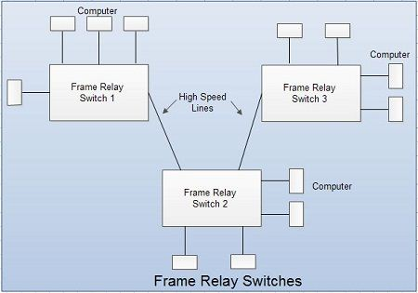

• The process of forwarding a packet has been illustrated.                            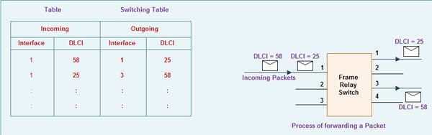

• The Frame Relay switch of Fig. has three incoming and four outgoing interfaces.

• The incoming interface-l receives two packets wit~ DLCI numbers 58 and 25.

• The switching table for the frame relay switch is shown in Table.

• As per this table the packet with DLCI number 58 is forwarded to the outgoing interface-

3 and that having DLCI number 25 is forwarded to interface-I.

**Frame relay frame:**The structure of the Frame Relay frame shown in the figure. The Frame Relay package, very similar to the X.25 package, has the following components:

• Figure Shows the frame relay frame format. This frame is very similar to the HDLC frame except for the missing control field here.

• The control field is not needed because flow and error control are not needed.

• The Flag, FCS and [information](https://ecomputernotes.com/fundamental/information-technology/what-do-you-mean-by-data-and-information) fields are same as those of HDLC.

• The address field defines the DLCI along with some other bits required for congestion control and traffic control.

• Their description is as follows:

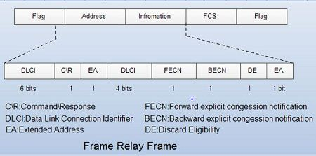**1. DLCI field:**

The first part of DLCI is of 6 bits and the second part is of 4 bits. They together form a 10 bit data link connection identifier.

**2. Command / Response (C / R):**

The C/R bit allows the upper layers to identify a frame as either a command or response. It is not used by the frame relay protocol.

**3. Extended Address (EA):**

• This bit indicates whether the current byte is the final byte of the address.

• If EA = 1 it indicates that the current byte is the final one but if EA = 0, then it tells that another address byte is going to follow.

**4. Forward Explicit Congestion Notification (FECN):**

• This bit can be set by any switch to indicate that traffic is congested in the direction of travel of the frame.

• The destination is informed about the congestion via this bit.

**5. Backward Explicit Congestion Notification (BECN):**

• This bit indicates the congestion in the direction opposite to the direction of frame travel.

• It informs the sender about the congestion.

**6. Discard Eligibility (DE):**

• The DE bit indicates the priority level of the frame. In the overload situations a frame may have to be discarded.

• If DE = 1 then that frame can be discarded in the event of congestion.

• DE bit can be set by the sender or by any switch in the network.

Extended address (Frame Relay Assembler *I*Disassembler) :

The frame relay address has been extended from the original 2 byte address to 3 or 4 byte address, in order to increase the range of DLCIs.

**FRADs:**

• FRAD (Frame Relay Assembler/Disassembler) is a device used by frame relay to handle frames arriving from other protocols.

• A FRAD assembles and disassembles frames coming from other protocols.

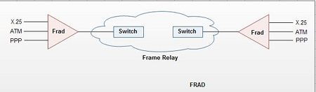**VOFR:**

• This is an option offered by frame relay. Its long form is Voice Over Frame Relay.

• VOFR allows voice transfer on the frame relay. Voice is transferred in the digital form with the help of PCM.

• This is an inexpensive way of sending voice over long distance. But the quality of sound is not very good.

**LMI:**

• Originally there was no provision for control and management of interfaces in the frame relay because it was designed to provide PVC connection.

• So recently a protocol called LMI (local management information).

• This protocol provides management features such as :

1. A mechanism to check if data is flowing.

2. A multicast mechanism.

3. A mechanism to check the status of a switch.

**Congestion control and quality of service:**

One of the advantages of frame relay is that it provides congestion control and quality of service.

**Advantages of frame relay:**

Some of the advantages of frame relay are:

1. Streamlined communication process.

2. The number of functions of a protocol at the user-network interface is reduced.

3. Lower delay.

4. Higher throughput.

5. Frame relay can be used at access speeds upto 2 Mbps.

6. Frame Relay is cost- effective, partly due to the fact that the network buffering requirements are carefully optimized.

7. Compared to X.25, with its store and forward mechanism and full error correction, network buffering is minimal.

8. Frame Relay is also much faster than X.25: the frames are switched to their destination with only a few byte times delay, as opposed to several hundred milliseconds delay on X.25.

**Disadvantages of frame relay:**

1. Frames are delivered unreliably.

2. Packets may not be delivered in the same sequence as that at the sending end.

3. Packets having errors are simply discarded.

4. Frame relay does not provide flow control.

5. It does not provide the acknowledgement of received packets.

6. Frame discarded in case of network congestion. If congestion occurs in the network, frame (data) is discarded within the network without re-transmission of this frame. The sender must perform re-transmission control at his own responsibility.

**Congestion control in frame relay networks:**

• The frame relay network implements a simple congestion control mechanism in which involves congestion notification.

• The two congestion notification mechanisms are as follows:

1. FECN : Forward Explicit Congestion Notification.

2. BECN: Backward Explicit Congestion Notification.

• Both these are controlled by a single bit contained in the frame header of frame relay.

• The frame header of frame relay also contains a Discard Eligibility (DE) bit. It is useful in identifying the less important traffic which can be dropped in the event of congestion.

• The FECN bit is a part of the address field of the frame header.

• If the network is congested, the FECN bit is set to 1. When such frames reach the destination, the FECN = 1 indicates the presence of congestion. The flow control can then be initiated or the indication may be ignored.

• As shown in Fig. the FECN bit travels to the destination i.e. in the direction of transmission.

• The BECN bit also is a part of the address field of the frame header.

• The value of BECN bit is set to 1 in the frames that traveling in the opposite direction (to the sender).

• The BECN = 1 indicates congestion and the flow control is exercised to control the congestion.

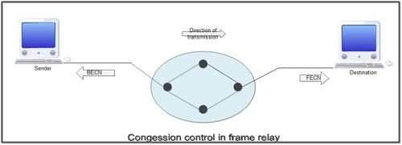**Discard Eligibility (DE):**

• If “DE” bit of a frame is set to 1 then it shows that, the particular frame has lower importance than the other frames.

• In the event of congestion, the frames with DE = 1 are discarded first to reduce the possibility of critical data getting affected by the congestion.

## **Frame Relay and the OSI Reference Model**

Frame relay constitutes of the OSI second layer (data link layer). Above that layer the protocol may be determined as desired by the user. Therefore, the IP protocol (the third-layer protocol) which is commonly used for LAN can be used without any modification.